



Department of Empowerment of Persons with Disabilities,
Ministry of Social Justice and Empowerment, Government of India

Disability Certificate
District Civil Hospital
Parbhani, Maharashtra


Certificate No.: MH0420619680200284 Date: 19/03/2020
This is to certify that I/we have carefully examined Shri Shivgir Daulatgir Giri, Son of Shri Daulatgir Giri, Date of Birth 10/09/1968, Age 52, Male, Registration No. 2704/00000/2101/0264006, resident of House No. At Katoda, Post Gangalgaon-431720, Sub District Palam, District Parbhani, State / UT Maharashtra, whose photograph is affixed above, and I am/we are satisfied that:

(A) He is a case of Locomotor Disability
(B) The diagnosis in his case is OPERATED CASE OF LUMBER DISC WITH PARAPARESIS
(C) He has 45% (in figure) Forty Five percent(in words) Permanent Disability in relation to his as per the guidelines (Guidelines for the purpose of assessing the extent of specified disability in a person included under RPWD Act, 2016 notified by Government of India vide S.O. 76(E) dated 04/01/2018).
This certificate recommended for 5 year(s), and therefore this certificate shall be valid till 16/08/2028

The applicant has submitted the following document(s) as proof of residence:
Nature of Document(s): Aadhaar card
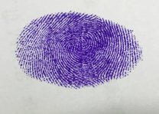


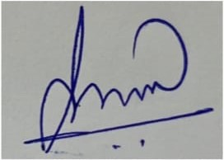
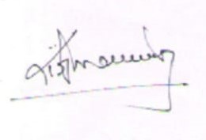
Signature / Thumb Impression of the Person with Disability


Signatory of the notified Medical Authority Member(s)



District Civil Hospital
Parbhani, Maharashtra

This Card/Certificate is meant to certify the disability of the person and is not an instrument for ID/Address Proof for any purpose.





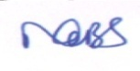

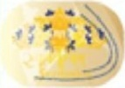
UNIQUE DISABILITY ID
Government of India

नाम / Name
शिवगीर दौलतगीर गिरी
Shivgir Daulatgir Giri
UD ID
MH1750419920200284
Disability Type
Hearing Impairment
Year of Birth % of Disability
1997 45% (Forty Five Percent)
Date of Issue Valid upto
12/08/2024 Permanent
UNIQUE DISABILITY ID
Government of India

STATE ID:
N/A

Aadhaar No.
********9103

Card Issuing Authority
District Civil Hospital, Parbhani, Maharashtra

